# SharePoint 2013 Demo – Working with Managed Metadata

## Estimated time to complete this demo

25 minutes

## Objectives

Demonstration of following capabilities in SharePoint 2013

* Create a taxonomy using the browser
* Create & modify a taxonomy using the server side API
* Create & modify a taxonomy using the client side API (CSOM)

## Computers in this demo setup

This demo uses virtual machines as described in the following table. Before you begin the demo, you must start the virtual machines and then log on to the computers.

|  |  |
| --- | --- |
| **Virtual Machine** | **Role** |
| {Supplied by Instructor} | Domain Controller |
| {Supplied by Instructor} | Actual SharePoint environment with Office client and other required software. |

All user accounts in this lab use the password {Supplied by Instructor}.

## Getting started with demo

In the files provided with the hands on lab, run the batch file called **SetupModule.bat** by double clicking it. This file will execute a PowerShell script that will create a new site collection at [http://intranet.contoso.com/sites/Ecm](http://intranet.contoso.com/sites/Ecm%20) .

# Using the Managed Metadata Term Store Manager

In this demo you will work with the Managed Metadata Term Store Manager, create a new term set and perform some common operations using the Term Store Manager.

## Step 1 - Explore the Term Store Management Tool from Central Administration

In this task you will access and explore the Term Store Management Tool from Central Administration.

* Begin this task logged on to **SP as CORP\Administrator**.

1. Launch Central Administration in browser by selecting the following: **Start 🡪 All Programs 🡪 Microsoft SharePoint 2013 Products 🡪 SharePoint 2013 Central Administration**).
2. Under **Application Management**, select **Manage Service Applications**.
3. In the list of service applications, select **Managed Metadata Service** to launch the Term Store Management Tool.
4. As a farm administrator you have access to manage the Managed Metadata Service settings, but not permissions within the service to create and modify term sets. To grant yourself access:
   * Enter **CORP\Administrator** in the **Term Store Administrators** section
   * Click the **Check Names** icon.
   * Click **Save**.

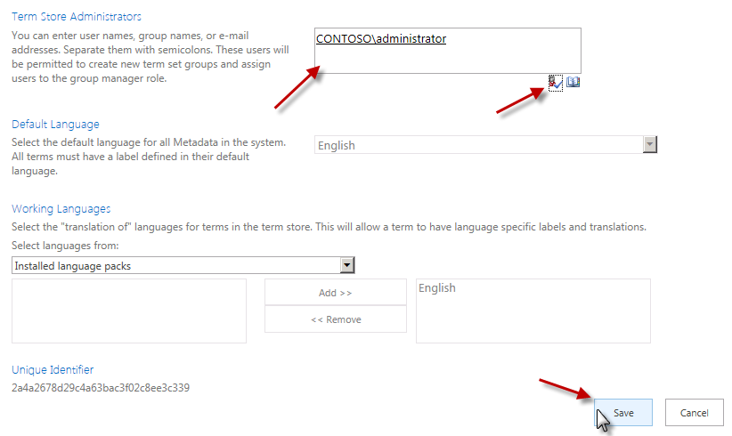

## Step 2 - Create a Term Set Using the Term Store Management Tool

In this task you will create and modify a new term set using the Term Store Management Tool.

* Begin this task logged on to **SP as CORP\Administrator**.

1. Within the **Term Store Management Tool**, select the **Managed Metadata Service** node in the left-hand part of the page and select **New Group**.

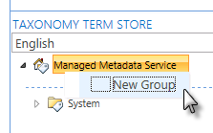

1. Set the name of the group to **Example Taxonomies**.
2. Select the **Example Taxonomies** group and select the drop-down **New Term Set**.
3. Set the name of the term set to **Corporate Locations**.
4. Select **Corporate Locations** term set and select **Create Term**. Use this technique to create a small taxonomy as shown in the following figure:

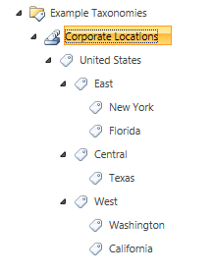

1. Now, select the **East** term. This term should not be available for tagging as it is only used to group terms. In the right-hand pane you will find the detail for this term.
2. Uncheck the **Available for Tagging** checkbox and click **Save**.

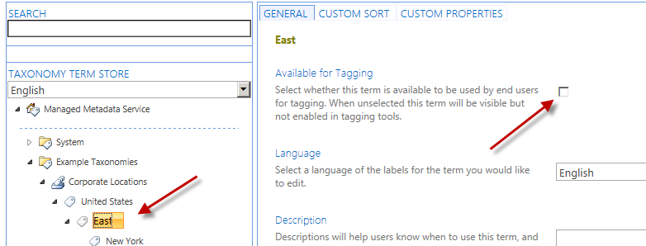

1. A new capability of the Term Store Management Tool is the ability to visually edit the custom properties on a term. Add a new property to signify the primary point of contact for a corporate region:
   * Select the **Texas** term.
   * In the right-hand pane, select the **Custom Properties** tab at the top.
   * Under the **Shared Properties**, select **Add**.
   * Name the property **PrimaryPOC** and give it a value of **Ken Sanchez** and click **Save**.

# Working with the Taxonomy Server-Side API

In this demo you will work with a taxonomy in the Managed Metadata Service programmatically using the server-side API.

## Step 1 - Create and Configure a New Visual Studio Project

In this task you will create a new project and configure everything necessary to work with the taxonomy in the term set.

* Begin this task logged on to **SP as CORP\Administrator**.

1. Launch Visual Studio by selecting **Start 🡪 All Programs 🡪 Microsoft Visual Studio 2012 → Visual Studio 2012**.
2. Create a new project:
   * Select **File 🡪 New 🡪 Project**.
   * In the left-hand section of the **New Project** dialog, select **Templates 🡪 Visual C# 🡪 Windows 🡪 Console Application**.
   * In the top part of the dialog, select **.NET Framework 4.5**.
   * Give the project a name of **TaxonomySSOM**.

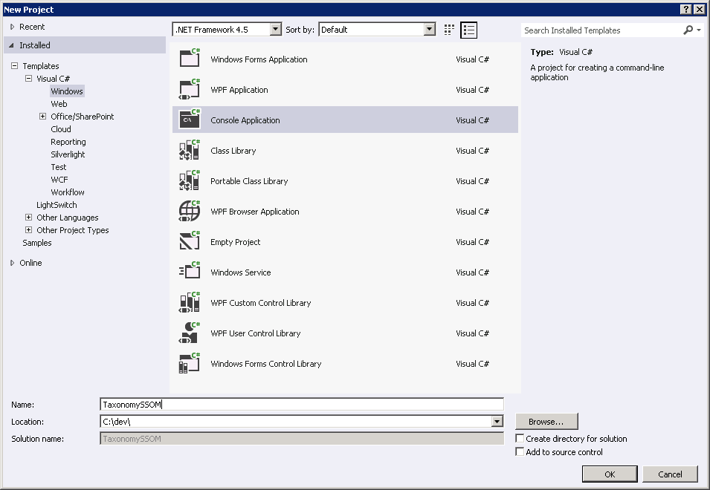

* + Click **OK** to create the project.

1. In order to work with the taxonomy API you need to add a few assembly references to the project:
   * Within the **Solution Explorer** tool window, right-click **References** in the project and select **Add Reference…**.

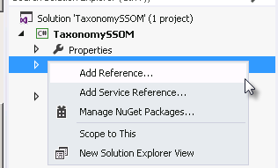

* + Click the **Browse** button at the bottom of the dialog and add the two assemblies found in the **c:\Program Files\Common Files\Web Server Extentions\15\ISAPI** folder:
    1. Microsoft.SharePoint.dll
    2. Microsoft.SharePoint.Taxonomy.dll
  + Click **OK** at the bottom of the dialog.

1. Finally, ensure this console application is a 64-bit application as SharePoint is 64-bit:
   * Right-click the project in the **Solution Explorer** and select **Properties**.
   * On the **Build** tab, select **Platform Target = x64**.
2. Save the project by clicking **File 🡪 Save All**.

## Step 2 - Create Terms in a Taxonomy

In this task you will write code to create terms in an existing taxonomy.

* Begin this task logged on to **SP as CORP\Administrator**.

1. Ensure the **TaxonomySSOM** is open and loaded within Visual Studio 11 that you created in the previous task.
2. Within the **Program.cs** file, add two using statements to save typing out the full type name later in the app:

using Microsoft.SharePoint;

using Microsoft.SharePoint.Taxonomy;

1. Now go into the **Main()** method. You need to get a reference to the term set previously created so the first step is to connect to a site collection, establish a taxonomy session and connect to the term set. Do this by adding the following code just inside the **Main()** method:

SPSite siteCollection = new SPSite("http://intranet.contoso.com/sites/ecm");

TaxonomySession taxSession = new TaxonomySession(siteCollection);

TermStore termStore = taxSession.TermStores[0];

Group termGroup = termStore.Groups.Single(tg => tg.Name == "Example Taxonomies");

TermSet termSet = termGroup.TermSets.Single(ts => ts.Name == "Corporate Locations");

1. With a reference to the term set, create a new region term and add a location to it. Add the following code after the code you just added to the **Main()** method:

// add region

Term unitedStatesTerm = termSet.Terms[0];

Term newRegion = unitedStatesTerm.CreateTerm("Mountain Region", 1033);

newRegion.SetCustomProperty("PrimaryPOC", "Janice Galvin");

newRegion.IsAvailableForTagging = false;

// add state

Term newState = newRegion.CreateTerm("Colorado", 1033);

// save changes

termStore.CommitAll();

1. Save your changes and press **F5** or **Debug 🡪 Start Debugging**. This will compile and execute the app. You will see the console application launch with a black box but because it doesn’t write anything to the console, nothing will be seen.
2. When the console app completes and the black box closes, check the changes you just made using the Term Store Management Tool:
   * Launch Central Administration in browser by selecting the following: **Start 🡪 All Programs 🡪 Microsoft SharePoint 2013 Products 🡪 SharePoint 2013 Central Administration**).
   * Under **Application Management**, select **Manage Service Applications**.
   * In the list of service applications, select **Managed Metadata Service** to launch the Term Store Management Tool.
   * Expand the **Example Taxonomies** group and find the terms you just added:

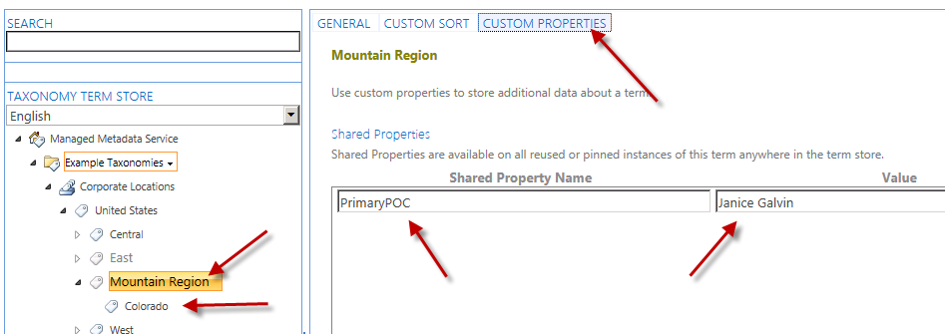

## Step 3 - Find and Modify Terms within a Taxonomy

In this task you will modify the console application created in the previous task to find a specific term in the term set and update it.

* Begin this task logged on to **SP as CORP\Administrator**.

1. Ensure the **TaxonomySSOM** is open and loaded within Visual Studio 11 that you created in the previous task and the **Program.cs** file is open.
2. The previous task had you run and test the console app. If you did that again you would get an error as it would try to recreate terms with the same name so comment out all the code that added a new region & state from the app. The **Program.cs** file’s **Main()** method should look like this:

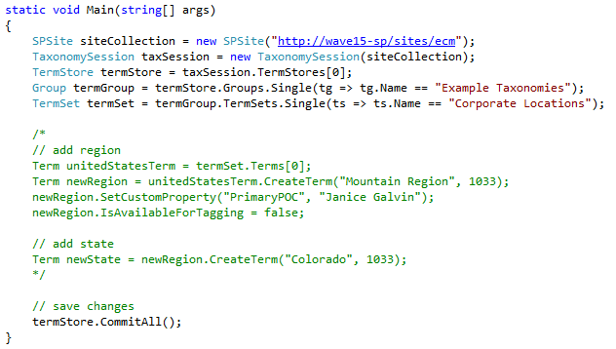

1. With the term creation code commented out, add some code to find a term. Insert the following code before the **// save changes** comment in the **Main()** method:

// search for CENTRAL term

var foundTerm = termSet.GetTerms("Central", 1033, false).First();

1. After finding the term, add code to update the title to include “Region” and to disallow tagging for the term:

foundTerm.Name = "Central Region";

foundTerm.IsAvailableForTagging = false;

1. Repeat the same process for the other two regions that were manually added:

// search for EAST term

foundTerm = termSet.GetTerms("East", 1033, false).First();

foundTerm.Name = "East Region";

foundTerm.IsAvailableForTagging = false;

// search for WEST term

foundTerm = termSet.GetTerms("West", 1033, false).First();

foundTerm.Name = "West Region";

foundTerm.IsAvailableForTagging = false;

1. Save your changes and press **F5** or **Debug 🡪 Start Debugging**. This will compile and execute the app. You will see the console application launch with a black box but because it doesn’t write anything to the console, nothing will be seen.
2. When the console app completes and the black box closes, check the changes you just made using the Term Store Management Tool:
   * Launch Central Administration in browser by selecting the following: **Start 🡪 All Programs 🡪 Microsoft SharePoint 2013 Products 🡪 SharePoint 2013 Central Administration**).
   * Under **Application Management**, select **Manage Service Applications**.
   * In the list of service applications, select **Managed Metadata Service** to launch the Term Store Management Tool.
   * Expand the **Example Taxonomies** group and find the terms you just modified:

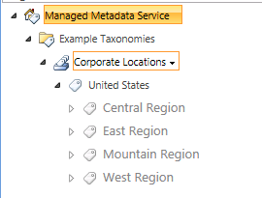

# Working with the Taxonomy CSOM API

In this demo you will work with a taxonomy in the Managed Metadata Service programmatically using the client side object model (CSOM) API.

## Step 1 - Create a new Visual Studio Project

In this task you will create a new project and configure everything necessary to work with the taxonomy CSOM in the term set.

* Begin this task logged on to **SP as CORP\Administrator**.

1. Launch Visual Studio by selecting **Start 🡪 All Programs 🡪 Microsoft Visual Studio 2012 → Visual Studio 2012**.
2. Create a new project:
   * Select **File 🡪 New 🡪 Project**.
   * In the left-hand section of the **New Project** dialog, select **Templates 🡪 Visual C# 🡪 Windows 🡪 Console Application**.
   * In the top part of the dialog, select **.NET Framework 4.5**.
   * Give the project a name of **TaxonomyCSOM**.
   * Click **OK** to create the project.
3. In order to work with the taxonomy API you need to add a few assembly references to the project:
   * Within the **Solution Explorer** tool window, right-click **References** in the project and select **Add Reference…**.
   * Click the **Browse** button at the bottom of the dialog and add the two assemblies found in the **c:\Program Files\Common Files\Web Server Extentions\15\ISAPI** folder:
     1. Microsoft.SharePoint.Client.dll
     2. Microsoft.SharePoint.Client.Runtime.dll
     3. Microsoft.SharePoint.Client.Taxonomy.dll
   * Click **OK** at the bottom of the dialog.
4. Save the project by clicking **File 🡪 Save All**.

## Step 2 - Create and Modify Terms in a Taxonomy

In this task you will write code to create terms in an existing taxonomy.

* Begin this task logged on to **SP as CORP\Administrator**.

1. Ensure the **TaxonomyCSOM** is open and loaded within Visual Studio 11 that you created in the previous task.
2. Within the **Program.cs** file, add two using statements to save typing out the full type name later in the app:

using Microsoft.SharePoint.Client;

using Microsoft.SharePoint.Client.Taxonomy;

1. Now go into the **Main()** method. You need to get a reference to the term set previously created so the first step is to connect to a site collection, establish a taxonomy session and connect to the term set. This all must be done through the CSOM’s ClientContext object. Do this by adding the following code just inside the **Main()** method:

ClientContext context = new ClientContext("http://intranet.contoso.com/sites/ecm");

TaxonomySession session = TaxonomySession.GetTaxonomySession(context);

context.Load(session, taxSession => taxSession.TermStores.Include(

taxStore => taxStore.Groups.Include(

taxGroup => taxGroup.TermSets.Include(tax => tax.Name)

)));

context.ExecuteQuery();

TermStore termStore = session.TermStores[0];

TermGroup termGroup = termStore.Groups[0];

TermSet termSet = termGroup.TermSets[0];

1. With a reference to the term set, create a new region term and add a location to it. Add the following code after the code you just added to the **Main()** method:

// get UNITED STATES term

var terms = termSet.Terms;

context.Load(terms);

context.ExecuteQuery();

Term unitedStatesTerm = terms[0];

context.Load(unitedStatesTerm);

context.ExecuteQuery();

// add region

Term newRegion = unitedStatesTerm.CreateTerm("Pacific", 1033, Guid.NewGuid());

newRegion.SetCustomProperty("PrimaryPOC", "Rob Walters");

newRegion.IsAvailableForTagging = false;

// add state

Term newState = newRegion.CreateTerm("Hawaii", 1033, Guid.NewGuid());

// save changes

termStore.CommitAll();

context.ExecuteQuery();

1. Save your changes and press **F5** or **Debug 🡪 Start Debugging**. This will compile and execute the app. You will see the console application launch with a black box but because it doesn’t write anything to the console, nothing will be seen.
2. When the console app completes and the black box closes, check the changes you just made using the Term Store Management Tool:
   * Launch Central Administration in browser by selecting the following: **Start 🡪 All Programs 🡪 Microsoft SharePoint 2013 Products 🡪 SharePoint 2013 Central Administration**).
   * Under **Application Management**, select **Manage Service Applications**.
   * In the list of service applications, select **Managed Metadata Service** to launch the Term Store Management Tool.
   * Expand the **Example Taxonomies** group and find the terms you just added:

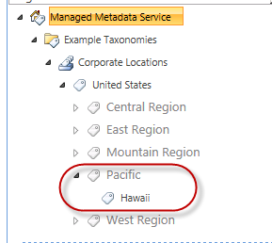

## Step 3 - Find Terms within a Taxonomy

In this task you will modify the console application created in the previous task to find a specific term in the term set and update it using the CSOM.

* Begin this task logged on to **SP as CORP\Administrator**.

1. Ensure the **TaxonomyCSOM** is open and loaded within Visual Studio 11 that you created in the previous task and the **Program.cs** file is open.
2. The previous task had you run and test the console app. If you did that again you would get an error as it would try to recreate terms with the same name so comment out all the code that added a new region & state from the app. The **Program.cs** file’s **Main()** method should look like this:

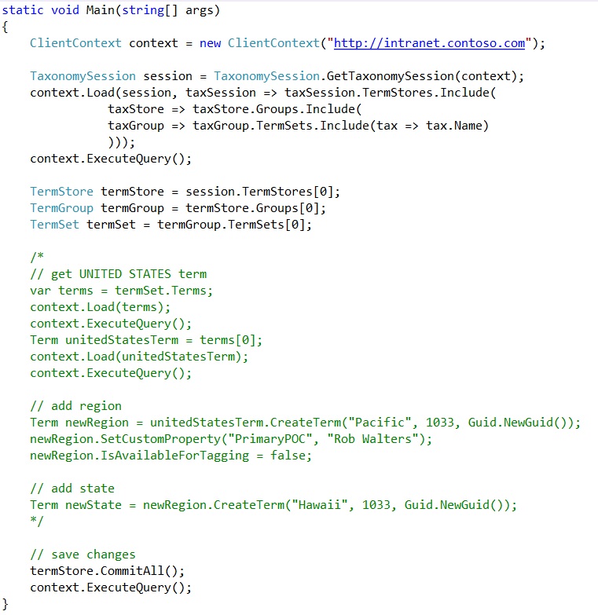

1. With the term creation code commented out, add some code to find a term. Insert the following code before the **// save changes** comment in the **Main()** method:

// search for PACIFIC term

var searchQuery = new LabelMatchInformation(context) {

TermLabel = "Pacific",

TrimUnavailable = false

};

var foundTerms = termSet.GetTerms(searchQuery);

context.Load(foundTerms);

context.ExecuteQuery();

1. After finding the term, add code to update the title to include “Region” and to disallow tagging for the term:

// update term

foundTerms[0].Name = "Pacific Region";

1. Save your changes and press **F5** or **Debug 🡪 Start Debugging**. This will compile and execute the app. You will see the console application launch with a black box but because it doesn’t write anything to the console, nothing will be seen.
2. When the console app completes and the black box closes, check the changes you just made using the Term Store Management Tool:
   * Launch Central Administration in browser by selecting the following: **Start 🡪 All Programs 🡪 Microsoft SharePoint 2013 Products 🡪 SharePoint 2013 Central Administration**).
   * Under **Application Management**, select **Manage Service Applications**.
   * In the list of service applications, select **Managed Metadata Service** to launch the Term Store Management Tool.
   * Expand the **Example Taxonomies** group and find the terms you just modified:

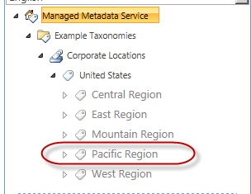

* This is the end of the demo